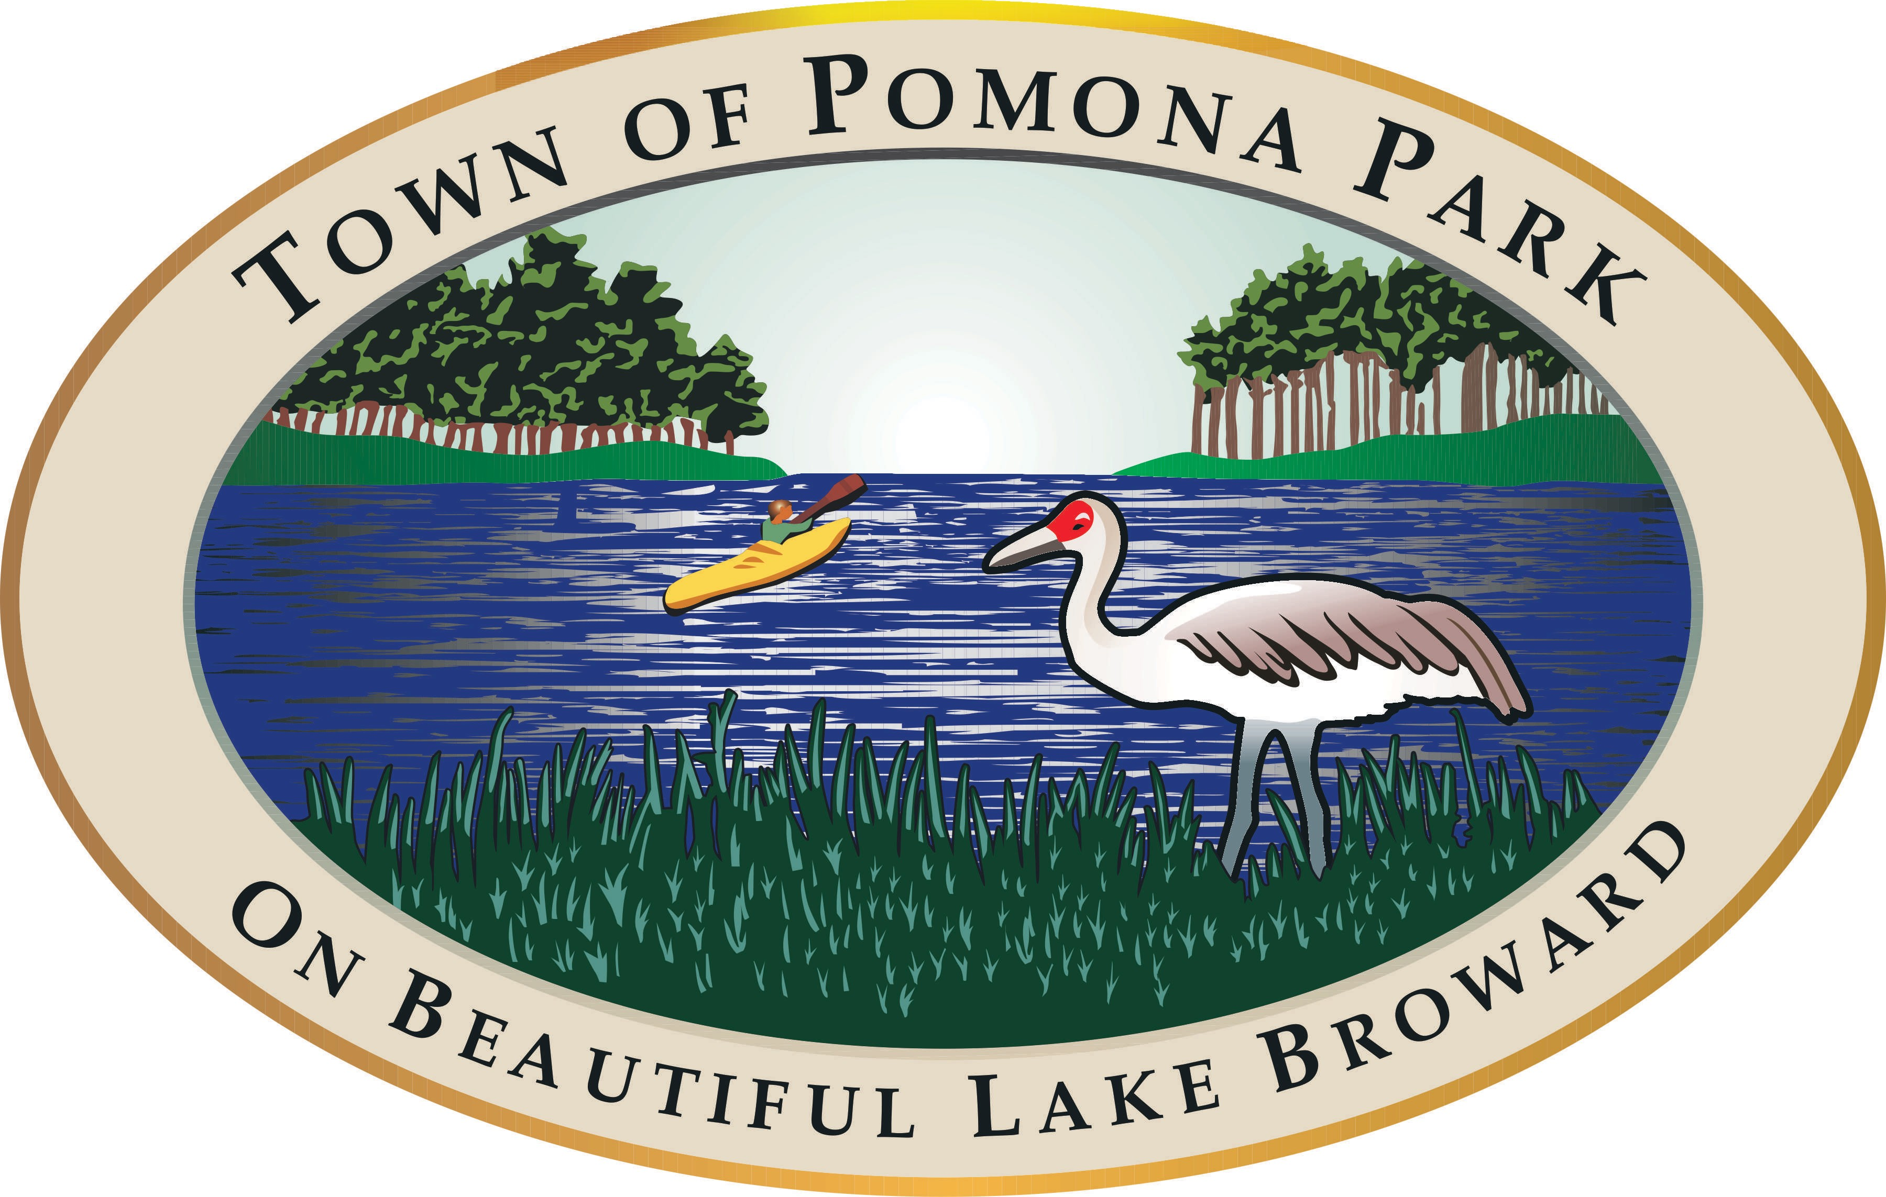Town of Pomona Park

**Agenda** Beautification Committee

***Chair Martha Mann Vice-Chair Yvonne Munn***

***Secretary June Ulrich***

Town Hall

1775 Hwy 17

Pomona Park, FL 32181 [www.pomonapark.com](http://www.pomonapark.com/)

**Monday, April 3, 2023, 6:00 PM Town Hall - Chambers**

* Public Participation shall be in accordance with Section 286.0114 Florida Statutes.
* Public comment on issues on the agenda or public participation shall be limited to 3 minutes.
* Other matters of concern may be discussed as determined by Committee during the meeting.
* If you wish to obtain more information regarding the agenda, please contact the Town Clerk’s Office at 386-649-4902.
* In accordance with the Americans with Disabilities Act and Section 286.26, Florida Statutes, persons needing a reasonable accommodation to participate in any of these proceedings or meeting should contact the Town Clerk at 386-649-4902, at least 48 hours prior to the meeting.
* It is proper meeting etiquette to silence all electronic devices, including cell phones while meeting is in session.
* The Town of Pomona Park is not responsible for any mechanical failure of recording equipment.
* Any person who decides to appeal any decision with respect to any matter considered at this meeting will need a record of the proceedings, and for such purpose, may need to hire a court reporter to ensure that a verbatim record of the proceedings is made, which record includes the testimony and evidence upon which the appeal is to be based.
  1. PLEDGE OF ALLEGIANCE
  2. ROLL CALL TO DETERMINE QUORUM
  3. REVIEW MARCH 6, 2023, MEETING MINUTES
  4. REVIEW INCOME AND EXPENSE REPORT
  5. REVIEW MONTHLY BREAKFAST
  6. COMMUNITY GARDEN/ REVIEW PHASE PLAN
  7. EASTER EGG HUNT
  8. OTHER UPCOMING EVENTS/RAFFLE/PLANTING PROJECTS
  9. PUBLIC COMMENT
  10. ADJOURN

Pomona Park Created on 1/31/23

1