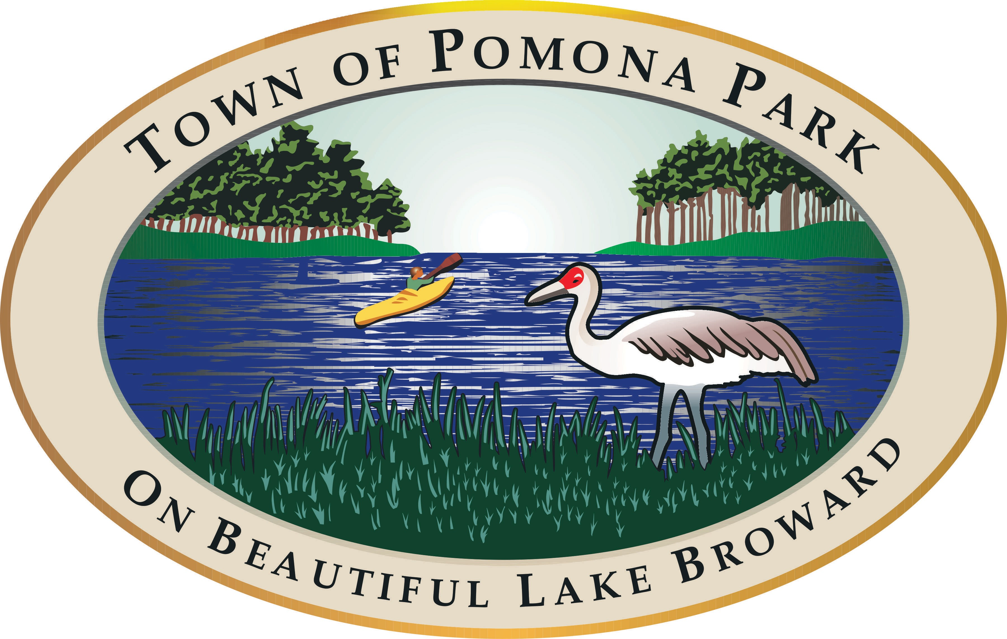
Town of Pomona Park
Agenda Beautification Committee
Chair Martha Mann Vice-Chair Yvonne Munn
Secretary June Ulrich
Town Hall
1775 Hwy 17 Pomona Park, FL 32181 www.pomonapark.com

Monday, April 8, 2024 6:00 PM Town Hall - Chambers

- Public Participation shall be in accordance with Section 286.0114 Florida Statutes.

- Public comment on issues on the agenda or public participation shall be limited to 3 minutes.

- Other matters of concern may be discussed as determined by the Committee during the meeting.

- If you wish to obtain more information regarding the agenda, please contact the Town Clerk’s Office at 386-649-4902.

- In accordance with the Americans with Disabilities Act and Section 286.26, Florida Statutes, persons needing a reasonable accommodation to participate in any of these proceedings or meeting should contact the Town Clerk at 386-649-4902, at least 48 hours prior to the meeting.

- It is proper meeting etiquette to silence all electronic devices, including cell phones while the meeting is in session.

- The Town of Pomona Park is not responsible for any mechanical failure of recording equipment.

- Any person who decides to appeal any decision with respect to any matter considered at this meeting will need a record of the proceedings, and for such purpose, may need to hire a court reporter to ensure that a verbatim record of the proceedings is made, which record includes the testimony and evidence upon which the appeal is to be based.

  - PLEDGE OF ALLEGIANCE

  - ROLL CALL TO DETERMINE QUORUM

  - REVIEW MINUTES FROM MARCH 4, 2024 MEETING

  - REVIEW INCOME/EXPENSE REPORT

  - REVIEW FIRST SATURDAY BREAKFAST

  - REVIEW EASTER EGG HUNT/ FRIENDS OF DUNN’S CREEK FUNDRAISER

  - FOUNDER’S DAY MARKET / CANDIDATE FORUM

  - BEAUTIFICATION AWARD

  - OTHER UPCOMING EVENTS/RAFFLE/PLANTING PROJECTS/MERCHANDISE

  - COMMUNITY GARDEN / GARDEN DEDICATION APRIL 20TH

  - PUBLIC COMMENT

  - ADJOURN

