Project Narrative

Pomona Park Resort at Dunns Creek

Application for Planned Unit Development (PUD)

**November 09, 2023**

Property Owner(s): Ken and Sue Nettles Triple R Investors, LLC

Project Applicants: John W. Horan, Emerald Coast Development

Matthew Morton, Emerald Coast Development

**Project Information:**

|  |  |
| --- | --- |
| Address(s) | 143 Sisco Road  151 Cisco Road  XX Unadressed |
| Parcel No(s) | 30-11-27-0000-0030-0000  30-11-27-0000-0080-0000  30-11-27-0000-0080-0010 |
| Total Acreage | 67.58 +/- |
| Existing Use | Vacant Land used for Agriculture and Recreation |
| Proposed Use | Signature amenity driven resort consisting of 213 Back in RV Sites, 26 Ultra Pull Thru RV Sites, 81 Pull Thru RV Sites and 45 Park Model Cabins |
| Current Zoning Designation(s) | Zoning: RM  FLUM: RM  Project Allowed through PUD Process |

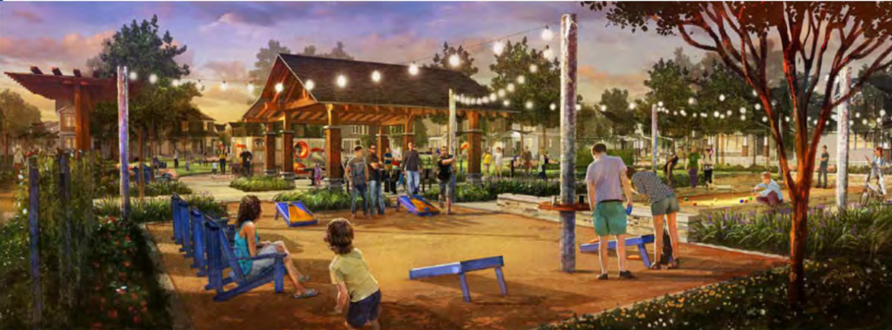

Figure Concept Rendering Amenity Area

**Project Background:**

The proposed site consists of three(3) parcels currently zoned RM by the Town of Pomona Park. The properties are currently vacant except for a small RV Homesite used by the current property owner(s) with an access off of Sisco Road. The property has been historically used for intermittent agriculture and was under past consideration for a site as both a Walmart SuperCenter and/or a large Residential Home Subdivision.

The current proposal of a Resort Development through a PUD process was chosen, *inter alia*, the following reasons:

1. **The Pomona Park Resort will have a lower impact to city services as compared to other types of allowed development** - Tourism driven development that is commercial in nature tends to generate more revenue (sales tax) than they demand back in services. A quantitative analysis conducted by the Strong Towns Institute focused on the Fiscal Impacts of Residential Growth [2014 & 2017] estimated a revenue gap of $8,000 per single family home per year annually for new single family subdivisions, while development with commercial activity can generate far more revenue than it utilizes of local government resources, thereby helping ameliorate the tax burden on existing single family homes by creating revenue. [<https://actionlab.strongtowns.org/hc/en-us>]
2. **Job Creation** - Preliminary Estimates demonstrate that the Pomona Park RV Resort at Dunns Creek could generate up to 27 Full Time or Full Time Equivalent Jobs Local Jobs such as:
   1. Park Manager(s)
   2. Camp Hosts
   3. Maintenance (Site, Amenity, Grounds)
   4. Housekeeping
   5. Customer Service
   6. Food and Beverage
   7. Activities Specialists
   8. Aquatic & Recreation Facility Staff
3. **Recreational Tourism Compatibility** & **Wellbeing** - The United States Department of Agriculture published extensive research findings on Rural Tourism and Recreational Development [Economic Research Report 7]. The study found that rural recreational development (businesses) leads to higher employment growth rates and a higher percentage of working-age residents who are employed. Earnings and income levels are also positively affected. Rural tourism and recreational development results in lower local poverty rates and improvements in other social conditions, such as local educational attainment and health (measured by mortality rates). The one growth-strain measure examined in the study, commuting time to work, revealed little evidence of traffic congestion in rural recreation areas. [https://www.ers.usda.gov/webdocs/publications]
4. **Positive Economic Impact** - The June 2022 RVIA Economic Impact Analysis summarized the following economic benefits to the State of Florida:
   1. $3 Billion spent in RV Travel in Florida
   2. $785 Million in tax revenue related to RV Industry in Florida
   3. $2 Billion in wages associated with RV Industry in Florida

Similarly, the State of Florida found in 2017 that Dunns Creek State Park reported 53,905 visitors in the 2016-2017 Fiscal year with an average economic impact of $124.08 expended per person per day with a regional economic impact of $5.5 million dollars. We believe data supporting the Pomona Park RV Resort at Dunns Creek will increase park visitation and concentrate a larger portion of tourism within the Town of Pomona Park. [https://www.rvia.org/rvs-move-america-economic-impact-study]

**5. Access/Traffic/Roads/Pedestrian Access:**

Roads inside the project will be built to required standards as designated by the Town of Pomona Park and/or Putnam County but maintained privately by the project owner. The project is proposed to have primary ingress/egress located off of Sisco Road with on-site RV queuing and parking for registrants to prevent stopping or queuing on Sisco Road. Secondary/emergency ingress and egress is proposed off US Highway 17. All access points will be designed, engineered and constructed to the standards of the Town of Pomona Park, Putnam County and the Florida Department of Transportation as required.

The main access will constitute a proposed 44’ wide road section and a minimum 50-foot naturally vegetated and landscaped buffer the length of the frontage off Sisco Road to minimize both traffic and visual impacts. The entrance will be an attractive landscaped and setback divided median entrance.

Pedestrian Access will be facilitated with a system of proposed on and off track alignments with the goal of coordinating bicycle, pedestrian and possibly equestrian access to Dunns Creek State Park through the Friends of Dunns Creek and the State of Florida Parks Service.

**6. Water**

Water for the project is proposed to be private and provided by three existing (3) on-site wells. Water treatment and distribution systems will be designed and approved by the Florida Department of Health. Water System pre-design meetings have occurred with the Florida Department of Health, Dr. Cecil Slaughter in Tallahassee, to confirm feasibility and design requirements.

Similarly water required for irrigation, resort amenities and fireflow will be provided by the three (3) existing on-site wells and/or on-site storage as required.

**7. Waste Disposal**

Sewerage is proposed to be handled on-site via MBR or Septic design that accommodates daily loading requirements for RV Spaces and amenity requirements. The project proponent has explored several on-site systems compatible with the project and local site and soil conditions. Project preference is a high-tech contained baffled and chambered septic system with odor filtration. While septic is a lower cost option (as compared to a package plant or MBR system) this choice preserves the project's capability and readiness to migrate to public sewer once available on the US Highway 17 Corridor, which is the best permanent option for sewerage.

**8. Utilities**

All onsite utilities will be undergrounded and will directly serve amenities and specific to each site. Florida Power and Light will be the electrical provider. Garbage and recycling will be provided by the Town/County approved waste hauler. Wildlife resistant central trash collection points will be constructed.

**9. Wildlife**

Preliminary survey of the site provided no evidence of Gopher Tortoise or other critical species habitat. All State of Florida requirements will be followed pertaining to wildlife and species including review and permitting through the Florida Department of Environmental Protection and the St. Johns River Water Management District.

**10. Neighborhood Compatibility/Buffering/Landscaping**

The Pomona Park RV Resort at Dunns Creek seeks to enhance the rural character and “sense of place” of Pomona Park and be compatible with surrounding land uses to the maximum extent practicable.

The property is located in Medium Density Residential Zoning and fronts both US Highway 17 and Sisco Road. The site adjoins properties that are various zoning designations in the vicinity and have land uses comprising residential and commercial uses. The site is predominantly dry uplands, with generally flat topography and covered in grasses that have been generally harvested annually.

Initial measures taken in preliminary design to ensure compatibility and minimize disruption to surrounding areas and land uses include:

1. A Minimum 50-foot landscape and natural vegetative buffer was designed to surround the entire project. This significant dedication of buffer space is intended to enhance compatibility, mitigate lighting impacts and control dust. This represents and almost 12.5 Acre dedication if buffer space.
2. Main ingress and egress on Sisco Road was designed with significant on-site queuing and stacking space to ensure Sisco Road remains uncongested and unimpeded while queuing guests on the project interior with additional on-site check-in parking for RV’s.
3. Vegetated and landscaped berms will be designed along portions of Sisco Road frontage to minimize view and lighting impacts.
4. Interior landscaping will be congruent with new development and include the addition of trees and landscape plantings following a design plan. As a significant portion of the site is currently agricultural grassland, landscaping will increase the overall tree count and vegetative diversity.
5. Efforts will be made to retain existing on site trees, including mature oak trees for preservation and as an aesthetic design feature to enhance the character of the resort.

**11. Project Lighting**

Project lighting will be designed to be minimal and meet or exceed the requirements of “Dark Sky Compliance” with no light bleed to adjacent properties. For further information. [https://darksky.org/]

**12. Resort Structures, Management and Operations**

The Pomona Park RV Resort is intended to be a highly managed facility with careful attention paid to guest usage and activity, public safety, noise, waste removal and site conditions and providing a safe, fun and family friendly atmosphere.There is a proposed to be an on-site manager at all times. No wine, liquor or beer will be sold or provided by the Pomona Park RV Resort and we will not be seeking a liquor license for the RV Resort.

The resort will include various amenities and facilities such as laundry, a great lodge, swimming pool(s), tennis/pickleball, dog park and playground(s). The resort operator will maintain grounds, common areas, trails, equipment and utilities in a clean, safe and sanitary manner. No permanent on-site housing or residences are proposed.

Campfires may be allowed and will be restricted to designated community gas/LP fire rings only, of which 2 are presently proposed in amenity facilities. Wood burning fires are intended to be prohibited. The two (2) community fire rings will be subject to all requirements of the State of Florida and County Fire District Requirements and may utilize propane as a fuel source to eliminate smoke and reduce associated fire hazards.

The resort will provide nightly rentals on a year-round basis. Late Check-in’s, while available, will be discouraged and guests will be encouraged to check in/out between the hours of 7am-7pm.

Quiet Hours will generally be from 7PM to 7AM and during peak season(s) or Holidays may be extended to include the hours of 9:30PM to 7AM.

RV and park model cabin sites will be clearly marked and numbered. Every site will sufficiently accommodate associated parking and overflow/guest parking areas will be provided on-site. No parking is allowed on roads, drive aisles or maneuvering areas.

Park Model Cabana Cabins are designed to accommodate guests without RV’s or guests accompanying guests with RV’s. Cabana Cabins share a particular high-end resort design and are geared for short term accommodation only. (See Representation Below)

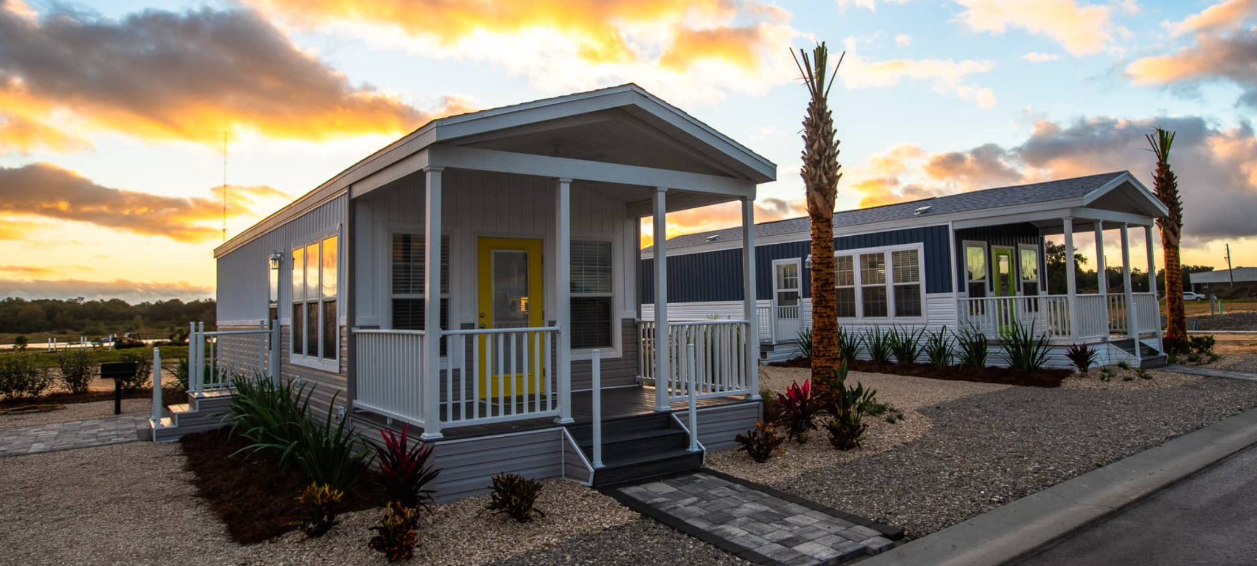

Figure Cabana Cabin Example from MV Auburndale, FL

**14.** **On Site Amenities and Activities**

The current site plan details two main “pods” or locations for resort amenities. On-site amenities will be managed and curated to complement local recreational tourism and outdoor recreation opportunities of the area. Planned recreational activities include;

1. Swimming pool(s) with associated water play features such as a splash pad, lazy river and/or water slide.
2. Facilities (multi-purpose or stand alone) for Tennis. Pickleball and Basketball.
3. Standalone or multipurpose courts for bocce ball, shuffleboard, etc.
4. A “bark-park” pet play and exercise area.
5. A seasonal/limited snack bar (NO ALCOHOL)
6. Networked on-trax trail and path alignment for walking
7. Mini Golf Course and/or Putting Green
8. Parking for Community Food Truck(s) during events
9. Extensive curated activities such as arts and crafts, trivia, sports games and tournaments, presentations on local geography and wildlife, classes, etc
10. Central restroom and shower facilities for Resort “Pods”.



Figure Pool and Bath House at Amenity Pod 2 Concept Rendering

**12.** **Local Economic Synergy & Local Sourcing**

The Pomona Park RV Resort at Dunns Creek looks to enhance Local Economic Synergy by:

1. Diversification of Economic Activities - Supporting, where possible, a diverse range of economic activities within the community, which can include, among other things; buying products, goods, and services locally and by integrating local agriculture, handicrafts, tourism, and local knowledge within relevant industries into operations.
2. Collaboration and Networking - Fostering collaboration among local businesses, producers, and entrepreneurs to fill current and future needs for both servicing resort guests and the activities of managing and maintaining the Resort.
3. Community Engagement - Supporting and strengthening community values and culture through support of community initiatives and programs that align with the vision, mission and operations of the Pomona Park RV Resort at Dunns Creek.

**14. Consistency Analysis of How the PUD Request is Compatible with Town of Pomona Park Land Development Code**

We believe the proposed Pomona Park RV Resort at Duns Creek is compatible with the stated purposes and objectives of the The Town of Pomona Park Land Development Code (LDC) wherein **Sec. 90-8(a-e)** describes the purpose of a Planned Unit “*to provide an opportunity for innovative urban design techniques, improved use of land, [to] develop a desirable land use mix*…*to encourage the unified development of large tracts of land using more creative and flexible concepts in site planning than would otherwise be possible through the strict application of maximum and minimum requirements of conventional [established zoning]. The PUD may contain any mixture of residential, commercial…and recreational land so long as these uses are made compatible through spatial or buffering techniques.*

*AND*

***Sec. 90-8 (1)(a-b) PUD defined; permissible uses:***

*a.For the purpose of this chapter, a planned unit development (PUD) shall mean the development of land under unified control which is planned and developed as a whole in a single or programmed series of operations with uses and structures substantially related to the character of the entire development. A PUD must also include a program for the provision, maintenance, and operation of all areas, improvements, facilities, and necessary services for the common use of all occupants thereof.*

*B. Any use which is permitted or permissible by exception in any zoning district may be included in a PUD.*

**Consistency Analysis of How the Proposed Pomona Park RV Resort at Dunns Creek PUD supports/is compatible with the Goals, Policies and Objectives of the Town of Pomona Park Comprehensive Plan**

**Goal A.1** To develop and maintain land use programs and activities to build upon the existing foundation of a good working and living environment by directing new growth into areas which can accommodate reasonable growth, improve the quality of life and create a sound economic base with minimum adverse impact on the natural environment.

*Policy A.1.1.6 The Land Development Codes shall provide strategies, which maximize the use of existing facilities and services through redevelopment, infill development, and other strategies for revitalization.*

*Policy A.1.1.8 The Town shall encourage recreational sites and public services in blighted areas to encourage a better living standard.*

*Policy A.1.1.11 The Land Development Codes may provide incentives to the private sector to redevelop blighted areas, which may include density/intensity bonuses, mixed use/planned unit development, etc.*

**Goal F.1** The Town of Pomona Park shall ensure the provision of sufficient parks and recreational facilities to meet the needs of its residents and visitors.

*Objective F.1.2 The Town shall coordinate public and private resources to meet its recreational needs through implementing the following policies.*

*Policy F.1.3.5 The Town shall encourage multi-use trails and facilities along State and County Roads*